**To whom it may concerns,**

Thanks so much for considering my candidacy.

Here is a sample of my Matlab programming ability. Please find in next several pages one of my projects focuses on Expected Shortfall and VaR of Barrier options. For your information, I reorganized the paper to the following structure:

Appendix II: graphs – to illustrate the ending portfolio value of barrier options on different barrier value

Appendix III: codes – my codes to come up with ES and VaR estimations via Monte-Carlo method

Expected Shortfall and VaR Estimation of Barrier Option on Changing Barrier Value – the main body of the project paper explaining the methodology and results

Appendix I: results

First, I would like to share an email [from Prof. Blake LeBaron](http://www.brandeis.edu/global/faculty/facultyguide/person.html?emplid=3863836c60fea8a993359c6d2f71be423bc77a23) regarding this paper:



Yi,

Please forward this note on to your team members.

I just wanted to send you a quick note letting you know how much I enjoyed reading your group project. It was extremely well executed, and a really interesting idea. (I do kind of have a soft spot for the barrier option problem.) You completely analyzed the problem of moving the barrier around and how that impacts the hedging capability of the option. Not only did you do this, but your explanations and intuition on what was happening were excellent. (I learned a lot from reading these.)

This was one of the best projects I've seen in my many years of teaching fin285a. I may also try to incorporate some of these experiments into some of my future lectures in the class. Really interesting.

I gave you guys an A+ for the projects. Nice job.

Blake LeBaron

Thanks for your time!

Yi Zou

**Appendix II: Graph**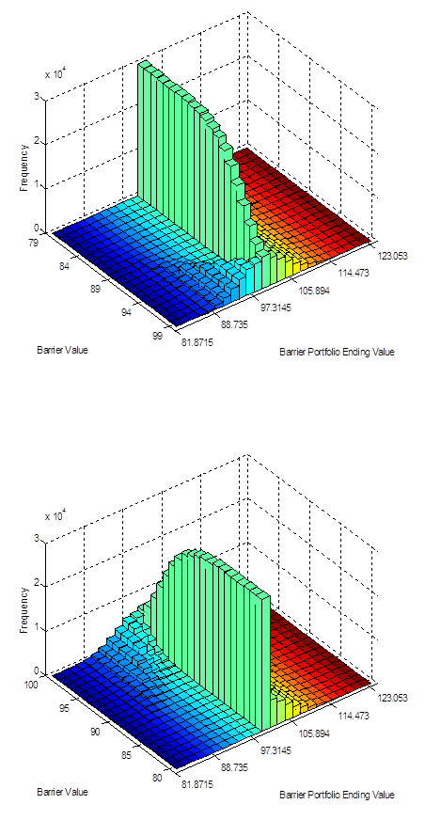

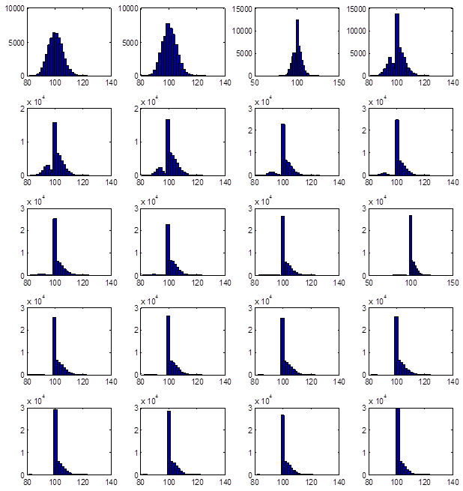

**Appendix III: Codes**

clear all

load dow.dat

p = dow(:,2);

ret1 = log(p(2:end)./p(1:end-1));

% set parameters

price = 100;

strike = 100;

barrierastart = 100;

options = 1;

shares = 1;

horizon = 20;

rf = 0.05;

varp = 0.05;

dowstd = std(ret1);

dowmean = mean(ret1);

% Risk neutral : return = risk free rate

% risk neutral mean

% x = lognormal(m,v)

% Expected growth in log(x) = m + v/2

rndowmean = rf/250 - dowstd^2/2;

% Expected price growth = 0.05/250 - v/2 + v/2 = 0.05/250

% stage one: Risk neutral option pricing

% Actualy, we use 5000000 instead of 50000 to come up with our results

niterat = 50000;

vanillaput = zeros(1,niterat);

barrierput = zeros(1,niterat);

record = zeros(1,20);

barrierport = zeros(20,niterat);

for j=1:20

% set barrier to 99:-1:80

barrier = barrierastart-j;

for i = 1:niterat

rets = normal(horizon,rndowmean,dowstd^2);

pricepath = [price; exp( cumsum(rets) ) *price];

vanillaput(i) = max(strike-pricepath(end),0);

pathmin = min(pricepath);

if(pathmin>barrier)

barrierput(i) = max(strike-pricepath(end),0);

else

barrierput(i) = 0;

end

end

% estimate the price of both two option

vanoptval(j) = exp(-rf*(horizon/250))*mean(vanillaput);

barrieroptval(j)= exp( -0.05*(horizon/250))*mean(barrierput);

% stage two: Get value at risk using true means

vanport = zeros(1,niterat);

unhedge = zeros(1,niterat);

for i = 1:niterat;

rets = normal(horizon,dowmean,dowstd^2);

pricepath = [price; exp( cumsum(rets) ) *price];

vanillaput(i) = max(strike-pricepath(end),0);

pathmin = min(pricepath);

if(pathmin>barrier)

barrierput(i) = max(strike-pricepath(end),0);

else

barrierput(i) = 0;

end

vanport(i) = shares*pricepath(end) + options*vanillaput(i);

barrierport(j,i) = shares*pricepath(end) + options*barrierput(i);

unhedge(i) = shares*pricepath(end);

end

% Find the starting costs of the portfolios

costvan = shares*price+options*vanoptval(j);

costbarrier = shares*price+options*barrieroptval(j);

costunhedge = shares*price;

% estimate Expected Shortfall - not discounting since only 20 days future

%critical value

vancrit = quantile(vanport,varp);

bp = barrierport(j,:);

barriercrit(j) = quantile((bp), varp);

unhedgecrit = quantile(unhedge,varp);

esvan(j) = costvan - vancrit;

% plot the barrier portfolio value

subplot(5,4,j)

[y, x] = hist(unhedge,25);

y2 = hist(bp,x);

bar([x'],[y2'], 1)

% if there is no value lies to the left of critical value, then the

% espected shortfall will be the same as the cost of the option

if count(bp<barriercrit(j))>0

% if there are not more than 5% value lying to the left of critical

% value, then we should take remaining value right on the critical

% value into account.

%'+1' is taking the value right on critical into account.

if niterat*varp > count(bp<barriercrit(j))+1

% use 'record' to keep track on how many value under certain criti-

% -cal level (0.05 in this case)is lying excatly on critical value

record(j)=niterat*varp - count(bp<barriercrit(j));

esbarrier(j) = ...

costbarrier - (sum(bp(bp<barriercrit(j)))+...

(niterat*varp-count(bp<barriercrit(j)))*...

barriercrit(j))/(niterat*varp);

else

record(j)=niterat*varp - count(bp<barriercrit(j))-1;

esbarrier(j) = costbarrier - mean(bp(bp<=...

barriercrit(j)));

end

else

record(j)=123;

esbarrier(j) = costbarrier - barriercrit(j);

end

% If the barrier drops down to below 82 then there is no portfolio with a

% value below crtical value

esunhedge(j) = costunhedge - mean(unhedge(unhedge<unhedgecrit));

% estimate VaR - not discounting since only 20 days future

varvan(j) = shares*price+options*vanoptval(j) - vancrit;

varbarrier(j) = shares*price+options*barrieroptval(j) - barriercrit(j);

var(j) = shares*price - unhedgecrit;

end

% display var and mean percentage change in value (risk, return)

'vanoptval'

vanoptval

'barrieroptval'

barrieroptval

'unhedged'

var

'vanilla hedge'

varvan

'barrier hedge'

varbarrier

'expected short-fall for unhedge portfolio'

esunhedge

'expected short-fall for vanilla-put portfolio'

esvan

'expected short-fall for barrier put portfolio'

esbarrier

'how many crit out of order'

record

figure;

[y, x] = hist(unhedge,25);

y2=hist(barrierport',x);

% flip y2 over~ just to show the graph in two sides

for m=1:20

mm(:,m)=y2(:,21-m);

end

x1 = [x(1) x(5:5:25)];

subplot(2,1,1)

bar3(mm',1);

axis([0 26 0 21 0 30000]);

set(gca,'xticklabel',x1);

set(gca,'yticklabel',79:5:99);

xlabel('Barrier Portfolio Ending Value');

ylabel('Barrier Value');

zlabel('Frequency');

hold on

grid on

subplot(2,1,2)

bar3(y2',1)

axis([0 26 0 21 0 30000]);

set(gca,'yticklabel',100:-5:80);

set(gca,'xticklabel',x1);

xlabel('Barrier Portfolio Ending Value');

ylabel('Barrier Value')

zlabel('Frequency');

figure;

subplot(1,3,1)

[y, x] = hist(unhedge,25);

yy = hist(barrierport(5,:),x);

bar([x'],[yy'], 1);

xlabel('Barrier Portfolio Ending Value');

ylabel('Barrier Value = 95');

subplot(1,3,2)

[y, x] = hist(unhedge,25);

yy = hist(barrierport(9,:),x);

bar([x'],[yy'], 1);

xlabel('Barrier Portfolio Ending Value');

ylabel('Barrier Value = 91');

subplot(1,3,3)

[y, x] = hist(unhedge,25);

yy = hist(barrierport(15,:),x);

bar([x'],[yy'], 1);

xlabel('Barrier Portfolio Ending Value');

ylabel('Barrier Value = 80');

**Expected Shortfall and VaR Estimation of Barrier Option on Changing Barrier Value**

# ***Introduction***

We choose barrier option as the topic of our group project because barrier options change distribution of profit and loss from continues distribution to partially discrete distribution; therefore impact VaR and Expected Shortfall. We are all very interested to explore the changes in VaR, especially Expected Shortfall by using barrier options. In this group project, we focused our study on Expected Shortfalls as well as VaR with different barrier values of a barrier put option. We also compared Expected Shortfalls (ES) and VaR of portfolios with barrier option with those of portfolios with vanilla put option and un-hedged portfolio.

# ***How to Do this***

We adjusted the code in barrieroptvar.m and developed some new code to solve the above problem. First, we created a big for-loop, changing the barrier value from 99 to 80, and output prices, VaRs and ESs under each condition.

In order to calculate the ES of barrier hedged portfolio, we estimated the following three different scenarios using different ways (barrieroptes.m: line 92 to line 115). We used ‘record’ to keep track on which one of these three scenarios was happening in certain cases:

1. If the critical value lies in the left tail (record = 0): using mean function could easily get the ES in this case

2. If the critical value lies in the middle hedged peak (0<record<5%*total amount) : we should take the value lies exactly on critical value into account using sum function and then dividing by 5% of total amount.

3. If there is no value lies in the left side (record = 5%*total amount): in this case, no stock had ever hit the barrier which means barrier option act like a vanilla option. ES should equal to that of the portfolio with vanilla option.



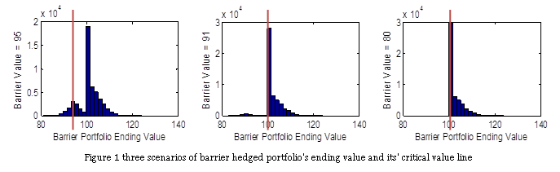

We attached the codes and result in Appendix I, II & III. In order to give more accurate results, we ran a 5,000,000 time simulation. For your convenience, the simulation times are 50,000 in the codes we attached.

# ***What did We get***

**Output Explanation**

|  |  |
| --- | --- |
| vanoptval | – Price of vanilla put option |
| barrieroptval | – Price of barrier put option |
| var | – VaR of unhedged portfolio |
| varvan | – VaR of hedged portfolio using vanilla put option |
| varbarrier | – VaR of hedged portfolio using barrier put option on different barrier value |
| esunhedge | – Expected shortfall of unhedged portfolio |
| esvan | – Expected shortfall of hedged portfolio using vanilla put option |
| esbarrier | – Expected shortfall of hedged portfolio using barrier put option on different barrier value |
| record | – Indicate how many ending value is exactly equal to the critical value, by following equation: record = niteral*varp - count(barrierport<barriercrit) |

**Cost of Options**

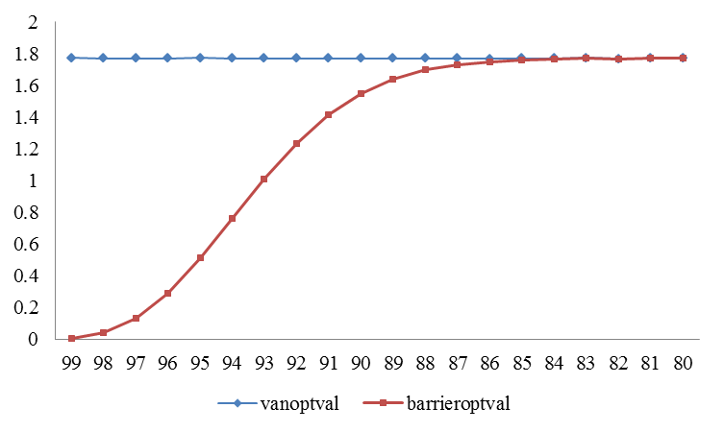Figure 2 Cost of vanilla put option and barrier option

Figure 2 reflects how the price of barrier put option and vanilla option change in terms of different barrier prices. From the 5,000,000 times simulation result, the price of vanilla put option is bouncing around 1.77 and does not change by different barrier values. On these 20 barrier values, the price of a barrier put option is always lower than that of a vanilla option. Since the barrier option will not be effective as long as the price hits barrier during a period, barrier option requires a stricter condition for the execution of option. Therefore, barrier put option is always cheaper than vanilla put option.

Another trend shown from the graph is that prices of barrier and vanilla put option converge as barrier becomes lower than certain level. The horizon we used in our model is 20 days, and we assumed the log return follows normal distribution. Hence, there will be certain case where all simulated portfolios have not hit the barrier value during such a short period. The lower the barrier value is, the lower the probability of price hitting the barrier. In our case, it is almost impossible for the stock price to hit the barrier lower than 82. Therefore, we can find the convergence trend of barrier and vanilla option prices.

**Expected Shortfall**

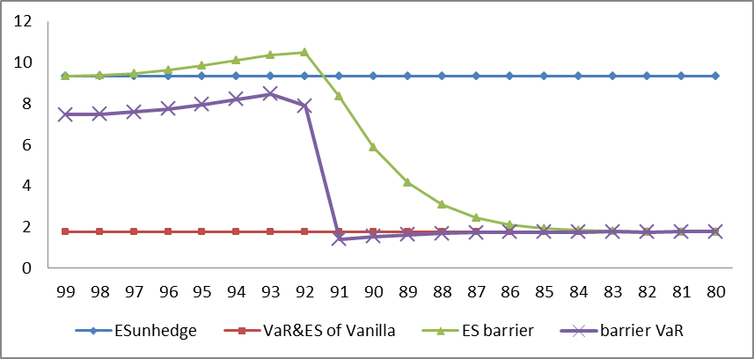Figure 3 Expected Shortfall & VaR of Barrier hedged, Vanilla put option hedged and Unhedged portfolio

1. VaR of Vanilla = ES of Vanilla = the cost of Vanilla option

This is because the striking price of this put option is the same with the beginning stock price. Vanilla put option won’t be ineffective by the moving of stock price. Therefore, it can lock the stock price and the investors will only have to pay for the option itself. If the price is going up, the cost of option will be deducted from the profit of selling stocks. If the price is going down, the investor will execute vanilla option and make sure the loss will not exceed the cost of option itself.

However, barrier put option is different. With the barrier going down, there will be a balance between the loss that option could save and the cost of option itself.

2. ES of barrier > VaR of barrier

ES took extreme left tail into account.

3. VaR of barrier > VaR of Vanilla when barrier value >= 92

More than 5% of portfolio’s barrier is ineffective and therefore left tail appears.

4. VaR of barrier < VaR of Vanilla when barrier value <= 91

Less than 5% of the portfolio’s barrier is ineffective and therefore even though there is value lying on left tail, the VaR lies in the hedged side. And because the costs of barrier option are always less than that of vanilla option, the VaR of barrier would be lower than that of vanilla.

5. ES of barrier > ES of unhedged and is increasing while barrier value >= 92

In the first eight trials, when barrier decreases from 99 to 92, the ‘record’ vector equals zero. In these cases, the barriers are relatively high. There will be a bigger probability for the stock price to hit the barrier and thus the option expires. If the option is easy to expire, our portfolio is likely to be unprotected as in the un-hedged case. We calculated the ES difference between barrier option case and un-hedged case and the result is in the figure 4 below. When the barrier ranges from 92 – 99, the ES difference is just the cost on the barrier put option. In this case, the barrier is so high that the portfolio is unprotected. The ES of barrier option case is just the sum of ES in the unprotected case and the cost of barrier option.

6. ES of barrier < ES of un-hedged model and is decreasing to converge with ES of Vanilla model

From barrier of 92, the protection on stock price from option begins to offset the cost of barrier option, and ES in barrier portfolio falls quickly and approaches the ES in vanilla portfolio. When the barrier hits 83 or lower, barrier ES is almost the same with vanilla ES. In this case, the barrier is so low that there is quite a small probability for the stock price to hit the barrier in a 20-day period. Therefore, the barrier option can be treated as a vanilla option.

|  |  |  |  |  |  |  |
| --- | --- | --- | --- | --- | --- | --- |
| Barrier  (A) | esunhedge  (B) | esbarrier  (C) | barrieroptval  (D) | esbarrier–esunhedge  (C - B) | barriervar  (E) | Record **  (F) |
| 99 | 9.3333 | 9.3387 | 0.0054 | 0.0054 | 7.4615 | 0 |
| 98 | 9.3244 | 9.3641 | 0.0397 | 0.0397 | 7.4928 | 0 |
| 97 | 9.3247 | 9.4554 | 0.1307 | 0.1307 | 7.5892 | 0 |
| 96 | 9.3333 | 9.6248 | 0.2915 | 0.2915 | 7.7499 | 0 |
| 95 | 9.3307 | 9.8423 | 0.5116 | 0.5116 | 7.9663 | 0 |
| 94 | 9.33 | 10.0917 | 0.7617 | 0.7617 | 8.2208 | 0 |
| 93 | 9.3319 | 10.3441 | 1.0122 | 1.0122 | 8.4702 | 0 |
| 92 | 9.3286 | 10.487 | 1.2335 | 1.1584 | 7.8913 | 0 |
| 91 | 9.3374 | 8.3317 | 1.4141 | -1.0057 | 1.4141 | 67531 |
| 90 | 9.3337 | 5.8577 | 1.5461 | -3.476 | 1.5461 | 147054 |
| 89 | 9.3313 | 4.1739 | 1.64 | -5.1574 | 1.6400 | 194823 |
| 88 | 9.3289 | 3.0989 | 1.6983 | -6.23 | 1.6983 | 221931 |
| 87 | 9.3307 | 2.4594 | 1.7326 | -6.8713 | 1.7326 | 236525 |
| 86 | 9.3249 | 2.0991 | 1.7503 | -7.2258 | 1.7503 | 243968 |
| 85 | 9.3327 | 1.926 | 1.7625 | -7.4067 | 1.7625 | 247356 |
| 84 | 9.3325 | 1.8369 | 1.7675 | -7.4956 | 1.7675 | 248951 |
| 83 | 9.3251 | 1.8005 | 1.7718 | -7.5246 | 1.7718 | 249592 |
| 82 | 9.3295 | 1.7762 | 1.7673 | -7.5533 | 1.7673 | 249879 |
| 81 | 9.3272 | 1.7733 | 1.7699 | -7.5539 | 1.7699 | 249957 |
| 80 | 9.3312 | 1.7707 | 1.7696 | -7.5605 | 1.7696 | 249986 |
| Vannilla Put Option |  | ES | Vanoptval |  |  |  |
|  |  | 1.7711 | 1.7711 |  |  | 250000 |

# ***Conclusion***

All in all, ES of barrier option provides us a different method to estimate the risks on barrier-option-hedged portfolios. When we compare ES with VaR of barrier portfolio as well as VaR of unhedged portfolios and Vanilla Option hedged portfolios, we found out certain routine and explained the different between these indicators. We think that Expected Shortfall could provide a more conservative evaluation of the risk since ES can show more details on extreme fat tail than VaR.

**Appendix I: results**

|  |  |  |  |  |  |  |  |  |  |  |
| --- | --- | --- | --- | --- | --- | --- | --- | --- | --- | --- |
| Barrier | vanoptval | barrieroptval | unhedged VaR | vanilla hedged VaR | barrier hedged VaR | ESunhedge | Esvan | ESbarrier | esbarrier - esunhedge | Record |
| 99 | 1.7726 | 0.0054 | 7.4561 | 1.7726 | 7.4615 | 9.3333 | 1.7726 | 9.3387 | 0.0054 | 0 |
| 98 | 1.7718 | 0.0397 | 7.4531 | 1.7718 | 7.4928 | 9.3244 | 1.7718 | 9.3641 | 0.0397 | 0 |
| 97 | 1.7701 | 0.1307 | 7.4585 | 1.7701 | 7.5892 | 9.3247 | 1.7701 | 9.4554 | 0.1307 | 0 |
| 96 | 1.7718 | 0.2915 | 7.4583 | 1.7718 | 7.7499 | 9.3333 | 1.7718 | 9.6248 | 0.2915 | 0 |
| 95 | 1.7734 | 0.5116 | 7.4547 | 1.7734 | 7.9663 | 9.3307 | 1.7734 | 9.8423 | 0.5116 | 0 |
| 94 | 1.7723 | 0.7617 | 7.4591 | 1.7723 | 8.2208 | 9.33 | 1.7723 | 10.0917 | 0.7617 | 0 |
| 93 | 1.7718 | 1.0122 | 7.458 | 1.7718 | 8.4702 | 9.3319 | 1.7718 | 10.3441 | 1.0122 | 0 |
| 92 | 1.7702 | 1.2335 | 7.4581 | 1.7702 | 7.8913 | 9.3286 | 1.7702 | 10.487 | 1.1584 | 0 |
| 91 | 1.7717 | 1.4141 | 7.4621 | 1.7717 | 1.4141 | 9.3374 | 1.7717 | 8.3317 | -1.0057 | 67531 |
| 90 | 1.7706 | 1.5461 | 7.4612 | 1.7706 | 1.5461 | 9.3337 | 1.7706 | 5.8577 | -3.476 | 147054 |
| 89 | 1.7715 | 1.64 | 7.4534 | 1.7715 | 1.64 | 9.3313 | 1.7715 | 4.1739 | -5.1574 | 194823 |
| 88 | 1.7714 | 1.6983 | 7.4544 | 1.7714 | 1.6983 | 9.3289 | 1.7714 | 3.0989 | -6.23 | 221931 |
| 87 | 1.7704 | 1.7326 | 7.4529 | 1.7704 | 1.7326 | 9.3307 | 1.7704 | 2.4594 | -6.8713 | 236525 |
| 86 | 1.769 | 1.7503 | 7.4559 | 1.769 | 1.7503 | 9.3249 | 1.769 | 2.0991 | -7.2258 | 243968 |
| 85 | 1.7709 | 1.7625 | 7.4581 | 1.7709 | 1.7625 | 9.3327 | 1.7709 | 1.926 | -7.4067 | 247356 |
| 84 | 1.7713 | 1.7675 | 7.4526 | 1.7713 | 1.7675 | 9.3325 | 1.7713 | 1.8369 | -7.4956 | 248951 |
| 83 | 1.7733 | 1.7718 | 7.4523 | 1.7733 | 1.7718 | 9.3251 | 1.7733 | 1.8005 | -7.5246 | 249592 |
| 82 | 1.7678 | 1.7673 | 7.4561 | 1.7678 | 1.7673 | 9.3295 | 1.7678 | 1.7762 | -7.5533 | 249879 |
| 81 | 1.7701 | 1.7699 | 7.4591 | 1.7701 | 1.7699 | 9.3272 | 1.7701 | 1.7733 | -7.5539 | 249957 |
| 80 | 1.7696 | 1.7696 | 7.4576 | 1.7696 | 1.7696 | 9.3312 | 1.7696 | 1.7707 | -7.5605 | 249986 |